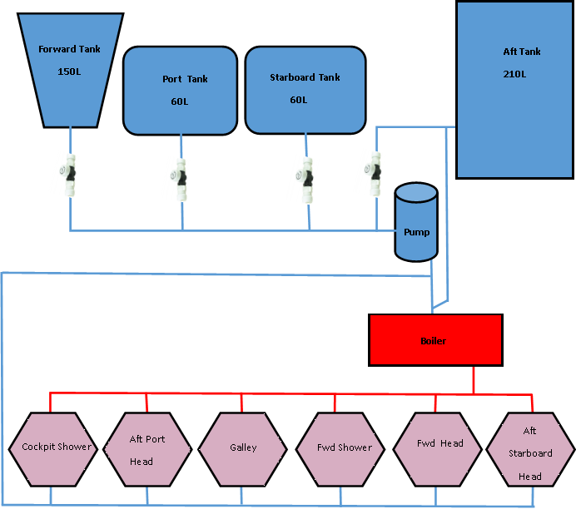

|  |  |
| --- | --- |
| The fresh water tank system on board Namadgi 3 is shown in schematic view above.  The four tanks on board should be filled separately. |  |
| Isolation valves are fitted for each tank so that you can choose to draw water from any of the tanks. This is in case one tank is polluted or leaking. The normal position for the Forward and Aft tanks valve should be ‘ON’. The normal position for the Port and Starboard Tank valves should be ‘OFF’ so that you can use the 60L tanks in the event of pollution or problem with the others. | Whale Ball Valve |
| The **Forward tank** holds 150 litres. The filler cap for this tank is located underneath the bow well hatch and is clearly marked with a blue ‘WATER’ sign. The tank itself is located under the bow well. Be careful when filling the tank not to spill water into the well as it will travel to the bilge. The isolation valve for the forward tank is located under the middle section of the port forward bunk. Lift the mattress to access the valve. It is the most forward valve visible in that section. | **ON** |
| The **Port and Starboard tanks** each hold 60 Litres. They each have a dedicated filler cap on the deck at either side of the bow which is clearly marked with a blue ‘WATER’ sign. The tanks are located under the middle section of the port and starboard forward bunks. Lift the mattresses to access. Their isolation valves are located on the aft port side of each tank. | **OFF** |
| The **Aft tank** holds 210 Litres. The filler cap for this tank is located under the cockpit floor beside the gas bottle and is clearly marked with a blue ‘WATER’ sign. The tank is located under the port aft bunk. The Aft tank should not be allowed to run dry because it is directly connected to the boiler. The isolation valve for the aft tank is located inside the cabinet in the port aft head alongside the water pump. | **ON** |
| The **Nav station monitor** shows the water level of the Forward and Aft tanks. To display water levels, press the forward most up/down selector button directly under the text display. Cycle through the options to see the readout for the Forward and Aft tanks. The reading will be most accurate when the boat is level. The reading is given in 25% increments only. |  |
| The Port and Starboard tanks **do not** show on the Nav Station monitor. Observe the level of tanks directly through the opaque tank wall if required. Do not open the inspection hatches. The large spiral hose attached to the blue hatch is the filler pipe. The small spiral hose attached to the blue hatch is the ‘breather’ hose, which vents to the anchor well, allowing air to replace the water as the tanks are drained, helping to allow the smooth passage of water through the pipe. The smallest white hose takes water to the water-pump to be distributed through the faucets. | C:\Users\Dee Taylor\AppData\Local\Microsoft\Windows\INetCache\Content.Word\DSCN3123.jpg |
| Water from all tanks runs back to the **water pump and strainer** in the port aft head where it becomes pressurised before being taken to all faucets on board. The strainer will be cleaned periodically to ensure smooth flow of water and protection of pump. The pump has an activation switch at the nav station – it is the middle button of the first column of icons and shows a tap over water symbol. | C:\Users\Dee Taylor\AppData\Local\Microsoft\Windows\INetCache\Content.Word\Picture Water Pump - Copy.jpg |
| Turn on the HWS in the 240 volt AC Electrical panel to charge hot water when connected to shore power.  Water is heated by the **boiler** under the port aft bunk. The boiler uses either mains shore power or heats via hot coolant from the steaming engine. When heating via shore power, the temperature is regulated to some degree. When heated via the engine, there is no temperature regulation and users should be **EXTREMELY careful** to always turn cold water on first and mix in hot slowly. Serious burns can result from onboard hot water.  Note that the boiler sits on a wooden plinth, allowing water pipes to travel underneath the boiler to reach the starboard aft cabin head. |  |
| The red knob on the lower port end of the boiler, where the blue cold water inlet pipes join the boiler case, is the pressure relief valve. That valve should be activated periodically to remove calcium deposits and ensure it is not blocked. Sigmar Marine water heaters also have a double thermostat with manual reset that shuts down power supply **in case of an excessive water temperature**.  If that happens:  • Shut down power supply  • Remove the square black plastic protection cover connected to the port side of tank in order to reach the thermostat.  • Push on the reset button below the thermostat knob  • Replace the protection cover  • Switch on power supply. (If it continues, seek professional advice) |  |
| On the following page is a diagram showing the position of key elements of the freshwater system on Namadgi 3. It shows the tanks, filler caps, through hull vents, water pipes (hot and cold), pump and boiler. Note that the configuration of the pipe system differs significantly from the diagram provided in the Bavaria owner’s manual. |  |

